**二年级看图写话图片和范文（1）：上学路上**

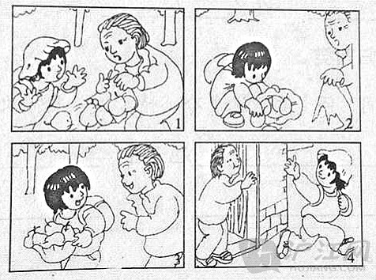

星期一的早晨，太阳当空照，小鱼背着书包，戴着漂亮的小红帽，高高兴兴地走在上学路上。这时，走在前面的老奶奶突然停了下来，小鱼跑上前一看，原来是老奶奶买的梨的袋子破了一个大洞，梨掉了一地。

这下可急坏老奶奶了：“袋子破了，我怎么拿回家去啊？老伴还等着我买梨回去呢！”小鱼看了看自己的书包，也没有可以装梨的袋子。就在这时，小鱼想到了一个好办法，她把自己的小红帽取下来，然后把老奶奶的梨一个一个地装进小红帽里。

老奶奶看到小鱼把梨装进了帽子里，非常高兴。小鱼这时说：“老奶奶，梨有点重，我送你回家吧！”老奶奶高兴地答应了。

就这样，小鱼捧着梨，把老奶奶送回了家。老奶奶一个劲地夸奖小鱼是个懂事的孩子。跟老奶奶道别后，小鱼心里美滋滋地直奔学校去。

**二年级看图写话图片及范文（2）：吹泡泡**

* 鼠标[划词](http://dict.hjenglish.com/snipper.aspx" \l "wrap" \t "_blank" \o "点击安装小d划词)[关闭划词](javascript:;" \o "小D划词翻译开/关)
* [收藏](javascript:;" \o "点击收藏该文章)
* [评论](http://xiaoxue.hujiang.com/yuedu/er/p272192/" \l "div_remark_redriect#div_remark_redriect" \o "去发表评论)
* [打印](http://xiaoxue.hujiang.com/print/272192/" \t "_blank" \o "#app_dayin)

**吹泡泡图片：**

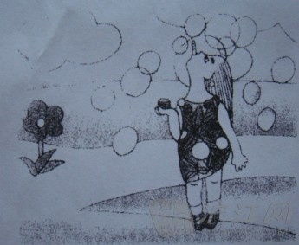

**吹泡泡范文：**

夏季的一天，阳光特别灿烂，蓝蓝的天上飘着朵朵像棉花糖一样的白云。我穿着漂亮的裙子，拿着一瓶泡泡水，高高兴兴地来到我家附近的公园。公园里有五颜六色的鲜花，还有绿油油的小草，真美丽呀！

我跑到草地上，小心翼翼地踮起了脚，吹起了泡泡来。我右手端着泡泡水，用嘴含着吹泡泡的管子，然后抬头小心翼翼地向上一吹，一下就吹出了好多泡泡，那泡泡像一串串的糖葫芦，又像一串一串的彩色气球，真漂亮呀！

**二年级看图写话图片及范文（3）：爷爷的乖孙子**

* 鼠标[划词](http://dict.hjenglish.com/snipper.aspx" \l "wrap" \t "_blank" \o "点击安装小d划词)[关闭划词](javascript:;" \o "小D划词翻译开/关)
* [收藏](javascript:;" \o "点击收藏该文章)
* [评论](http://xiaoxue.hujiang.com/yuedu/yi/p272193/" \l "div_remark_redriect#div_remark_redriect" \o "去发表评论)
* [打印](http://xiaoxue.hujiang.com/print/272193/" \t "_blank" \o "#app_dayin)

**爷爷的乖孙子图片：**

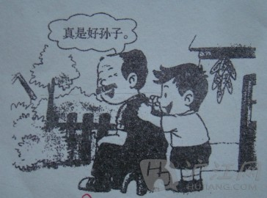

**爷爷的乖孙子范文：**

一天早上，明明和爷爷来到了花园里。明明说：“爷爷，你拔了这么多花花草草，一定很累了，我来给您锤锤背。”爷爷笑眯眯地说：“好啊，想谢谢小明！”

明明搬来一张小板凳，爷爷坐下了，明明轻轻地锤着爷爷的背，爷爷说：“小明真是爷爷的乖孙子！

中午，明明和爷爷回到家，爷爷把这件事告诉了爸爸妈妈和奶奶，大家都夸奖明明是一个孝顺的乖孩子！”

**二年级看图写话图片及范文（4）：小猫得救了**

* 鼠标[划词](http://dict.hjenglish.com/snipper.aspx" \l "wrap" \t "_blank" \o "点击安装小d划词)[关闭划词](javascript:;" \o "小D划词翻译开/关)
* [收藏](javascript:;" \o "点击收藏该文章)
* [评论](http://xiaoxue.hujiang.com/yuedu/liu/p272194/" \l "div_remark_redriect#div_remark_redriect" \o "去发表评论)
* [打印](http://xiaoxue.hujiang.com/print/272194/" \t "_blank" \o "#app_dayin)

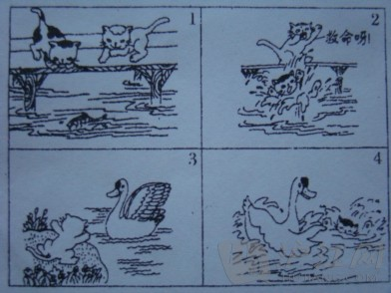

**小猫得救了范文：**

一天下午，小花和小白一起出门散步。

走到一座大桥时，忽然，小花看到河里一条又肥又大的鱼，它大叫起来：“小白，快看，这里有一条又肥又大的鱼。”小白说：“真的吗？那太好了！”小花心想：如果我把这条鱼捉了，那可以当这几天的美食了。

突然，小花不小心“扑通”一声掉进了河里。小花不会游泳，一直在刨水，眼看着就要淹死了，小白在岸上急得快要哭了，大声喊“救命呀！救命呀！”

一只大白鹅听见了，就赶快游到小花身边，它让小花爬到自己的背上来，小花用尽最后一点力气爬了上去，小猫终于得救了。

小白对小花说：“天哪！差点把我的心都摔碎了！不过，你掉进河里的姿势好像优美的舞姿呢！”大白鹅对小花说：“你以后到这里一定要小心哦！”小花说：“我知道了。”

从此，小猫到这里玩耍便知道很小心了。

**二年级看图写话图片及范文（5）：不要摘花**

* 鼠标[划词](http://dict.hjenglish.com/snipper.aspx" \l "wrap" \t "_blank" \o "点击安装小d划词)[关闭划词](javascript:;" \o "小D划词翻译开/关)
* [收藏](javascript:;" \o "点击收藏该文章)
* [评论](http://xiaoxue.hujiang.com/yuedu/wu/p272195/" \l "div_remark_redriect#div_remark_redriect" \o "去发表评论)
* [打印](http://xiaoxue.hujiang.com/print/272195/" \t "_blank" \o "#app_dayin)

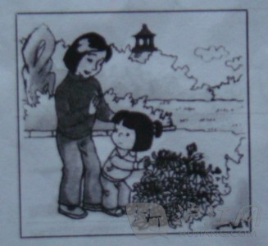

**不要摘花范文：**

一天上午，小红和妈妈一起去公园玩。

走着走着，小红突然看见几朵菊花掉在地上，她对妈妈说：“妈妈，我最喜欢菊花了，我能不能摘一朵呀？”妈妈温柔地对小红说：“摘花是可耻的行为。”小红特别听话，不摘花了。

从此，小红来公园不摘花了，而是仔细地观看，妈妈夸小红越来越乖了。

**二年级看图写话图片及范文（6）：洗手帕**

* 鼠标[划词](http://dict.hjenglish.com/snipper.aspx" \l "wrap" \t "_blank" \o "点击安装小d划词)[关闭划词](javascript:;" \o "小D划词翻译开/关)
* [收藏](javascript:;" \o "点击收藏该文章)
* [评论](http://xiaoxue.hujiang.com/yuedu/san/p272197/" \l "div_remark_redriect#div_remark_redriect" \o "去发表评论)
* [打印](http://xiaoxue.hujiang.com/print/272197/" \t "_blank" \o "#app_dayin)

**洗手帕图片：**

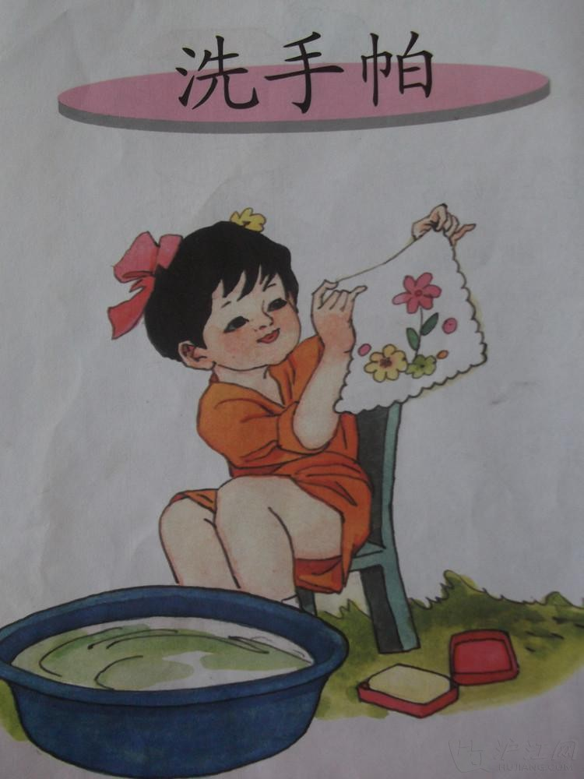

**洗手帕范文：**

星期六，阳光明媚万里无云。小红独自来到家里附近的公园散步，她往口袋掏糖果的时候，不小心把自己喜爱的小手帕掉在地上，拣起来一看，呀！弄脏啦！她着急地往家里赶……

回到家里小红先端来一盆水，接着把她的小手帕放在脸盆里，然后擦了一点肥皂，开始上搓搓，下搓搓。最后用清水冲洗干净。她把小手帕洗得象雪花一样雪白雪白的，小红还给了小手帕一个洁白的面孔，她感到十分开心！小红把手帕挂在阳台上晒太阳。这时一阵微风吹来，让小手帕在风的怀抱里荡秋千，好像在说：“嗨！小手帕你可真香啊！”小手帕自豪地说：“我的小主人小红刚刚给我洗过澡呢！我还正舒服着呢！”小红似乎听见了它们的对话，自言自语地说：“我是一个爱清洁讲卫生的女孩子，我的手帕自然要时时刻刻都干干净净……”

**二年级看图写话图片和范文（7）：送伞**

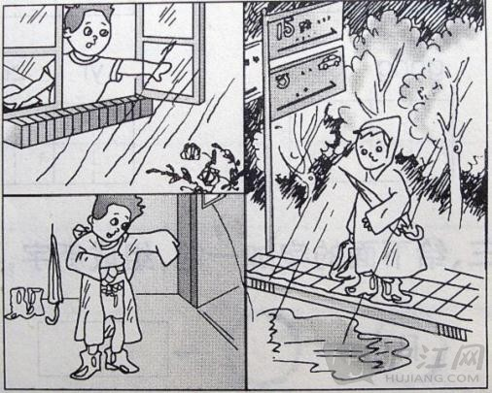

星期天早晨，小明在家里专心致志地做作业，妈妈提着篮子上街买菜去了。过了一会儿，天空中乌云密布，电闪雷鸣。小明吓了一跳，他赶紧跑到窗前一看，外面下起了倾盆大雨。小明担心地想：“妈妈出去没有带伞，淋了雨会感冒生病的，我得马上给她送伞去！”想到这里，他拿起雨伞，自己也撑了一把伞，大步流星地向菜场跑去。

外面的雨下得真大呀，雨点密密地斜织着，天地间像挂了无比宽大的珠帘。忽然，小明看见一个熟悉的身影，那是妈妈！只见她一手挎着菜篮，一手护着头，急匆匆地跑着。小明赶紧喊：“妈妈，妈妈，我给你送伞来了！”妈妈笑眯眯地接过雨伞，对小明说：“你真是个懂事的好孩子！”说完，小明和妈妈高高兴兴地回家了。

**二年级看图写话图片和范文（8）：粗心的小猫**

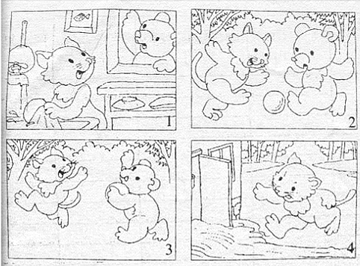

吃过午饭，小猫在厨房里洗碗。小熊闲着没事，就来找小猫：“小猫，我们一起去踢球吧！”小猫爽快地答应了。它急急忙忙地洗好碗，关上家门，就和小熊一起直奔球场。

在空旷的草坪上，小猫和小熊摆开阵势，奔来跑去，你攻我守，踢得满头大汗。小小的足球给它俩带来了无限的乐趣。

不知不觉，太阳下山了，小熊和小猫也觉得有些累了，就歇了脚，互相约定明天再一起玩，然后就各自回家了。

小猫刚走到家的附近，就发现家门口有一条小河，河水哗哗地流淌着。它奇怪地想，这是哪儿来的小河呢？难道是我们家发大水了吗？小猫赶紧跑到厨房一看，“呀，大事不妙，原来是中午洗碗忘记关水龙头了！小猫一个箭步上去，拧紧了水龙头。

看着一地的水，小猫非常后悔：都怪我太粗心了，浪费了这么多水！以后，做事情可一定要细心呀！

**二年级看图写话图片和范文（9）：气球又回来了**

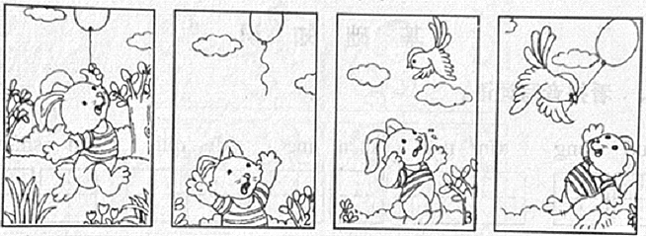

  一天，免妈妈在玩具店里给小白兔买了一个五颜六色的花气球，小白兔十分喜爱。回到家里，小白兔拿着气球一会儿跳到沙发上，一会儿跳到它爸爸面前炫耀……

小白兔对妈妈说：“妈妈，我可以带着的气球出去玩吗？”妈妈说：“可以。”小白兔连忙拿着自己的气球出去玩了。

小白兔来到离家不远的树林里，它在树林里活蹦乱跳。忽然一阵大风吹来，小白兔没有拿紧气球上的绳子，气球飞走了。小白兔焦急地看着在天空上越飘越高的气球，它心里急得连耳朵都变成“八字”形了。就在快看不见气球的身影时，小鸟姐姐飞来了，她正想找小白兔玩。小鸟姐姐看见小白兔着急的样子，就问小兔是怎么回事，小白兔把事情的原因告诉了小鸟姐姐，小鸟姐姐说：“我可以帮你。”说完，小鸟姐姐拍打着翅膀，箭一般地飞上了天空。过了一会儿，小鸟姐姐咬着气球的线回来了。小白兔看见了它心爱的气球，它那红红的眼睛就仿佛变成了一颗晶莹的红宝石，小白兔的耳朵也竖起来了。它非常感谢小鸟姐姐，便说：“谢谢你，小鸟姐姐。”小鸟连忙说：“不客气”。于是，它们在树林里高兴地一起玩着气球。

**二年级看图写话图片和范文（10）：保护庄稼的好朋友**

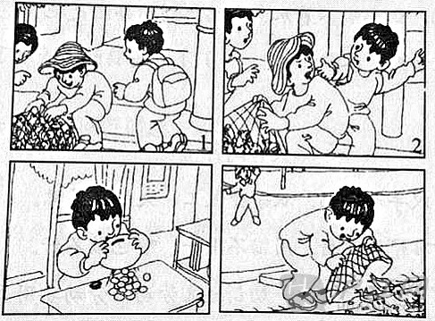

放学了，小明高高兴兴地走在回家的小路上。忽然，他看见一位贩子提着一只网罗，网罗里塞满了青蛙。那些青蛙有的呱呱地叫，有的使劲乱跳。

小明想：“青蛙是庄稼的卫士，怎么可以把它们抓起来呢？”正这样想着，小明看见一个人走过来，想买青蛙吃，小明着急了，他想：“保护青蛙人人有责，我要与他们说理去。”小明毫不犹豫地走过去，对那个贩子说：“你把青蛙放了，青蛙可是能保护庄稼的！”那贩子听了，怒气冲冲地说：“我抓来的青蛙是要卖钱的。你没有钱，就走开！”

小明一听，赶紧跑回家，他倒出了自己辛辛苦苦存在储蓄罐里的钱，拿给了那个小贩。小贩拿到钱，把青蛙一扔，走了。小明把网罗里的青蛙倒进小河里，看着那群快乐的小青蛙，小明也高兴极了！

**二年级看图写话图片和范文（11）：“对不起”和“没关系”**

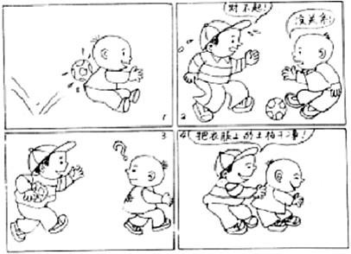

一天，小明正走在路上，突然感到后背一阵疼痛，好像被什么东西打到了，他转过头一看，原来是一个足球。这时，小刚急忙赶上来，连声说：“对不起！对不起！我是不小心的。”小明看着满头大汗、充满歉意的小刚，说：“没关系。”小明转身就走了。刚走不远，就听到小刚在后面喊：“请等一等！”小明很奇怪，转身问：“请问还有什么事吗？”小刚气喘吁吁地赶上来，说：“刚才的球把你的衣服弄脏了，让我帮你把衣服上的土拍干净！”说完，小刚轻轻地拍拍地把小明后背衣服上的泥土拍干净。小明高兴地说：“谢谢你！”小刚说：“不用谢，这是我应该做的！”

**二年级看图写话图片和范文（12）：捉蝌蚪**

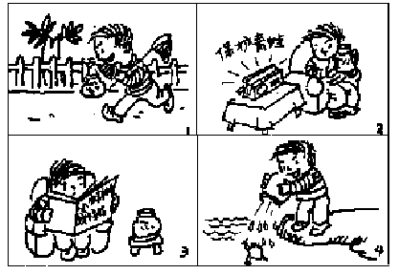

今天是星期天，天气很晴朗，天上漂浮着一朵朵白云。一丝丝风也没有。小明拿着网和瓶子兴高采烈地去抓蝌蚪。到了傍晚，他就抓了满满一瓶子蝌蚪。

回到家里，小明悠闲地坐在沙发上。正当他在观察蝌蚪的时候，突然听到收音机里在讲保护青蛙的知识，他立刻被吸引住了。然后，小明又拿起书仔细地看里面有关保护青蛙的知识。他知道自己错了。

第二天一早，小明立刻抱着装小蝌蚪的瓶子，跑到池塘边，把小蝌蚪放进了池塘，他对小蝌蚪说：“小蝌蚪，快快长大吧！长成青蛙，帮农民伯伯捉害虫吧！”

**二年级看图写话图片和范文（13）：我是“小眼镜”**

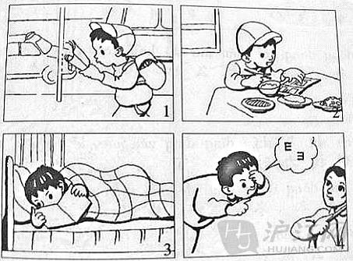

我是个“小书迷”，不管在哪儿都爱看书。

有时，我会在车上看书。一次在车上，我正捧着一本书津津有味地看着，身边一位老爷爷说：“别在车上看书，小心眼睛近视了。”我笑着说：“没关系，我眼睛好着呢！”有时，我会边走路边看书。一次，我不小心撞在了一棵大树上，还连连说“对不起”，逗得周围的人哈哈大笑！

每天晚上睡觉前，我也总要躺在床上看一会儿书，再甜甜地入睡。妈妈多次批评我，我总是嫌她唠叨。

可最近不知怎么啦，上课时黑板上的字老是模模糊糊的，看不清。妈妈带我去医院一检查，原来，我成近视眼了，只好戴上了眼镜。“小眼镜”的雅号从此就传开了。

**二年级看图写话图片和范文（14）：小白兔运南瓜**

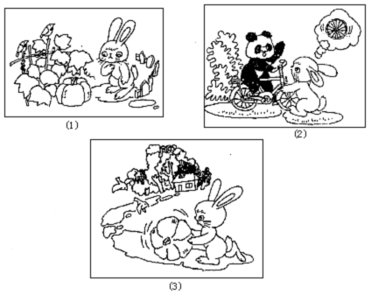

一个晴空万里、阳光明媚的早晨。天上飘着朵朵白云，今天是小兔子欢欢的生日，好多好多朋友都来祝贺小白兔生日快乐。兔妈妈非常热情，想到自家地里还种着许多大南瓜，妈妈高兴的说：“好吧，那你去南瓜地里帮妈妈摘一个大南瓜回来。”小白兔答应着就跑向地里。

小兔蹦蹦跳跳地来到南瓜地。只见绿油油的叶子有荷叶那么大，像一块块碧玉，金黄色的小花星星点点，可漂亮了。在大叶子下面长着一个个黄澄澄的大南瓜，小兔子飞快地走进南瓜地里，摸摸这个，又摸摸那个，自言自语地说：“每个都那么大，到底摘哪个好呢？”，最后她精心挑选了一个跟她差不多大的南瓜。小白兔抓住南瓜藤，双手用力一折，把南瓜藤折断了。“可是那么大的南瓜我怎么搬回家呢？”小兔想。小兔试着用手去搬，可是她用尽全身力气，南瓜像生了根似的，怎么也搬不动。它会一屁股坐在南瓜上，说：哎，我搬不动，怎么办呢？

小兔正在思考，这时她看见山羊伯伯骑着自行车路过，看着那圆滚滚的车轮，小兔心里一亮。既然车轮可以滚动，那我的大南瓜一定也可以滚动。想着，小兔把南瓜竖起来，推着南瓜飞快地跑回了家。

来到家门口，小兔轻轻地敲了敲门。兔妈妈急忙跑出来。看了看大南瓜，又看了看小兔，疑惑地问：“孩子，你是怎么把那么大的南瓜搬回来的？”小兔得意地说：“是我动脑筋把大南瓜运回来的。”小兔的妈妈竖起大拇指兴奋地说：“小兔真是个爱动脑筋的好孩子。”

**二年级看图写话图片和范文（15）：小刺猬，你别走**

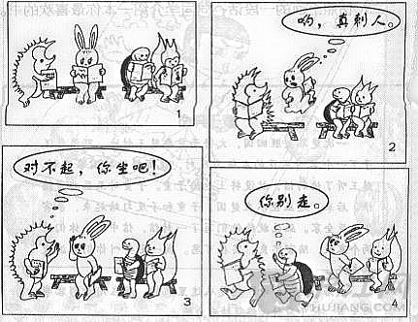

今天，风和日丽，小动物们都去动物园看书。它们分别是可爱的小白兔、聪明的小乌龟和活泼的松鼠。它们正看得津津有味呢！

突然，来了一只小刺猬，刺猬手上拿着书，看到小白兔旁边有个座位就坐了上去，可是它浑身是锋利而坚硬的刺，把小白兔给刺到了。

小刺猬连忙站起来说：“对不起小白兔，我不是故意的。”

小白兔摆摆手说：“不要紧。”

这时，小松鼠和小乌龟的目光也朝向了小白兔这边。

小松鼠微笑着说：“没事了，坐下来一起看书吧。”

小刺猬低着头说：“不用了，我怕再刺到你们，我还是去别的地方看书吧。”

正在这时，小乌龟灵机一动，想到身上的壳，它连忙跑过去说：“你别走，小刺猬，你和我坐吧，我身上有坚硬的壳不怕你的刺。”

后来，小刺猬就和聪明的小乌龟坐在一起看书。

瞧，这些可爱的小动物看书看得多么认真啊！

**二年级语文看图写话专项练习**

**1．看看图上是什么时候？都有谁？她们在哪儿？在干什么？想想她们在说什么？再写下来。 （手上拿着剪刀）**

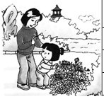

|  |  |  |  |  |  |  |  |  |  |  |  |  |  |  |  |
| --- | --- | --- | --- | --- | --- | --- | --- | --- | --- | --- | --- | --- | --- | --- | --- |
|  |  |  |  |  |  |  |  |  |  |  |  |  |  |  |  |
|  |  |  |  |  |  |  |  |  |  |  |  |  |  |  |  |
|  |  |  |  |  |  |  |  |  |  |  |  |  |  |  |  |
|  |  |  |  |  |  |  |  |  |  |  |  |  |  |  |  |
|  |  |  |  |  |  |  |  |  |  |  |  |  |  |  |  |
|  |  |  |  |  |  |  |  |  |  |  |  |  |  |  |  |
|  |  |  |  |  |  |  |  |  |  |  |  |  |  |  |  |
|  |  |  |  |  |  |  |  |  |  |  |  |  |  |  |  |
|  |  |  |  |  |  |  |  |  |  |  |  |  |  |  |  |
|  |  |  |  |  |  |  |  |  |  |  |  |  |  |  |  |

**2．仔细看看下面这幅图，写一个有趣的小故事。**

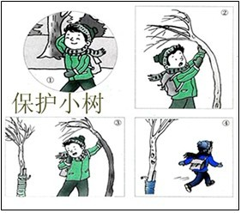

|  |  |  |  |  |  |  |  |  |  |  |  |  |  |  |  |
| --- | --- | --- | --- | --- | --- | --- | --- | --- | --- | --- | --- | --- | --- | --- | --- |
|  |  |  |  |  |  |  |  |  |  |  |  |  |  |  |  |
|  |  |  |  |  |  |  |  |  |  |  |  |  |  |  |  |
|  |  |  |  |  |  |  |  |  |  |  |  |  |  |  |  |
|  |  |  |  |  |  |  |  |  |  |  |  |  |  |  |  |
|  |  |  |  |  |  |  |  |  |  |  |  |  |  |  |  |
|  |  |  |  |  |  |  |  |  |  |  |  |  |  |  |  |
|  |  |  |  |  |  |  |  |  |  |  |  |  |  |  |  |
|  |  |  |  |  |  |  |  |  |  |  |  |  |  |  |  |
|  |  |  |  |  |  |  |  |  |  |  |  |  |  |  |  |
|  |  |  |  |  |  |  |  |  |  |  |  |  |  |  |  |

**3．看看图上都有谁？他们在什么地方？在干什么？再写下来。**

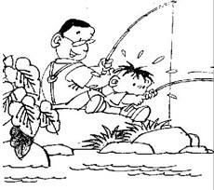

|  |  |  |  |  |  |  |  |  |  |  |  |  |  |  |  |
| --- | --- | --- | --- | --- | --- | --- | --- | --- | --- | --- | --- | --- | --- | --- | --- |
|  |  |  |  |  |  |  |  |  |  |  |  |  |  |  |  |
|  |  |  |  |  |  |  |  |  |  |  |  |  |  |  |  |
|  |  |  |  |  |  |  |  |  |  |  |  |  |  |  |  |
|  |  |  |  |  |  |  |  |  |  |  |  |  |  |  |  |
|  |  |  |  |  |  |  |  |  |  |  |  |  |  |  |  |
|  |  |  |  |  |  |  |  |  |  |  |  |  |  |  |  |
|  |  |  |  |  |  |  |  |  |  |  |  |  |  |  |  |
|  |  |  |  |  |  |  |  |  |  |  |  |  |  |  |  |
|  |  |  |  |  |  |  |  |  |  |  |  |  |  |  |  |
|  |  |  |  |  |  |  |  |  |  |  |  |  |  |  |  |

**4．看看下面这四幅图，你能看明白吗？试着写一写。**

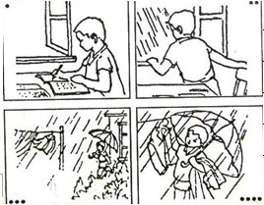

|  |  |  |  |  |  |  |  |  |  |  |  |  |  |  |  |
| --- | --- | --- | --- | --- | --- | --- | --- | --- | --- | --- | --- | --- | --- | --- | --- |
|  |  |  |  |  |  |  |  |  |  |  |  |  |  |  |  |
|  |  |  |  |  |  |  |  |  |  |  |  |  |  |  |  |
|  |  |  |  |  |  |  |  |  |  |  |  |  |  |  |  |
|  |  |  |  |  |  |  |  |  |  |  |  |  |  |  |  |
|  |  |  |  |  |  |  |  |  |  |  |  |  |  |  |  |
|  |  |  |  |  |  |  |  |  |  |  |  |  |  |  |  |
|  |  |  |  |  |  |  |  |  |  |  |  |  |  |  |  |
|  |  |  |  |  |  |  |  |  |  |  |  |  |  |  |  |
|  |  |  |  |  |  |  |  |  |  |  |  |  |  |  |  |
|  |  |  |  |  |  |  |  |  |  |  |  |  |  |  |  |

**5．**

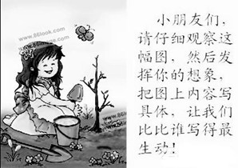

|  |  |  |  |  |  |  |  |  |  |  |  |  |  |  |  |
| --- | --- | --- | --- | --- | --- | --- | --- | --- | --- | --- | --- | --- | --- | --- | --- |
|  |  |  |  |  |  |  |  |  |  |  |  |  |  |  |  |
|  |  |  |  |  |  |  |  |  |  |  |  |  |  |  |  |
|  |  |  |  |  |  |  |  |  |  |  |  |  |  |  |  |
|  |  |  |  |  |  |  |  |  |  |  |  |  |  |  |  |
|  |  |  |  |  |  |  |  |  |  |  |  |  |  |  |  |
|  |  |  |  |  |  |  |  |  |  |  |  |  |  |  |  |
|  |  |  |  |  |  |  |  |  |  |  |  |  |  |  |  |
|  |  |  |  |  |  |  |  |  |  |  |  |  |  |  |  |
|  |  |  |  |  |  |  |  |  |  |  |  |  |  |  |  |
|  |  |  |  |  |  |  |  |  |  |  |  |  |  |  |  |

**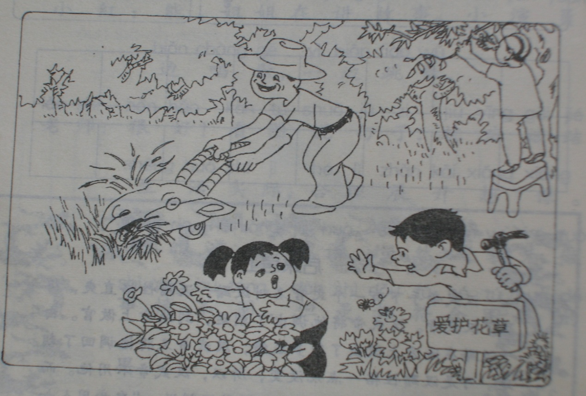6.看图写话。**

\_

|  |  |  |  |  |  |  |  |  |  |  |  |  |  |  |  |
| --- | --- | --- | --- | --- | --- | --- | --- | --- | --- | --- | --- | --- | --- | --- | --- |
|  |  |  |  |  |  | **爱** | **护** | **花** | **草** |  |  |  |  |  |  |
|  |  |  |  |  |  |  |  |  |  |  |  |  |  |  |  |
|  |  |  |  |  |  |  |  |  |  |  |  |  |  |  |  |
|  |  |  |  |  |  |  |  |  |  |  |  |  |  |  |  |
|  |  |  |  |  |  |  |  |  |  |  |  |  |  |  |  |
|  |  |  |  |  |  |  |  |  |  |  |  |  |  |  |  |
|  |  |  |  |  |  |  |  |  |  |  |  |  |  |  |  |
|  |  |  |  |  |  |  |  |  |  |  |  |  |  |  |  |
|  |  |  |  |  |  |  |  |  |  |  |  |  |  |  |  |
|  |  |  |  |  |  |  |  |  |  |  |  |  |  |  |  |

\_\_\_\_\_\_\_\_\_\_\_\_\_\_\_\_\_\_\_\_\_\_\_\_\_\_\_\_\_\_\_\_\_\_\_\_\_\_\_\_\_\_\_\_\_\_\_\_\_\_\_\_\_\_\_\_\_\_\_\_\_\_\_\_\_\_\_\_\_\_\_\_\_\_\_\_\_\_\_\_\_\_\_\_\_\_\_\_\_\_\_\_\_\_\_\_\_\_\_\_\_\_\_\_\_\_\_\_\_\_\_\_\_\_\_\_\_\_\_\_\_\_\_\_\_\_\_\_\_\_\_\_\_\_\_\_\_\_\_

7、仔细看图，能看懂图意吗？用一段话把故事写下来，并给故事起个题目。

\_\_\_\_\_\_\_\_\_\_\_\_\_\_\_\_\_\_\_\_\_\_\_\_\_\_\_\_\_\_\_\_\_\_\_\_\_\_\_\_\_\_\_\_\_\_\_\_\_\_\_\_\_\_\_\_\_\_\_\_\_\_\_\_\_\_\_\_\_\_\_\_\_\_\_\_\_\_\_\_\_\_\_\_\_\_\_\_\_\_\_\_\_\_\_\_\_\_\_\_\_\_\_\_\_\_\_\_\_\_\_\_\_\_\_\_\_\_\_\_\_\_\_\_\_\_\_\_\_\_\_\_\_\_\_\_\_\_\_\_

8、请小朋友认真观察图，然后以日记的形式把你看到的写下来。

**7.看图写话。**

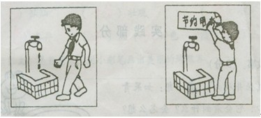

|  |  |  |  |  |  |  |  |  |  |  |  |  |  |  |  |
| --- | --- | --- | --- | --- | --- | --- | --- | --- | --- | --- | --- | --- | --- | --- | --- |
|  |  |  |  |  |  |  |  |  |  |  |  |  |  |  |  |
|  |  |  |  |  |  |  |  |  |  |  |  |  |  |  |  |
|  |  |  |  |  |  |  |  |  |  |  |  |  |  |  |  |
|  |  |  |  |  |  |  |  |  |  |  |  |  |  |  |  |
|  |  |  |  |  |  |  |  |  |  |  |  |  |  |  |  |
|  |  |  |  |  |  |  |  |  |  |  |  |  |  |  |  |
|  |  |  |  |  |  |  |  |  |  |  |  |  |  |  |  |
|  |  |  |  |  |  |  |  |  |  |  |  |  |  |  |  |
|  |  |  |  |  |  |  |  |  |  |  |  |  |  |  |  |
|  |  |  |  |  |  |  |  |  |  |  |  |  |  |  |  |

8.看图续编故事。

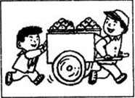

|  |  |  |  |  |  |  |  |  |  |  |  |  |  |  |  |
| --- | --- | --- | --- | --- | --- | --- | --- | --- | --- | --- | --- | --- | --- | --- | --- |
|  |  | 一 | 天 | 放 | 学 | 后 | ， | 李 | 明 | 走 | 在 | 回 | 家 | 的 | 路 |
| 上 | 。 | 这 | 时 | ， |  |  |  |  |  |  |  |  |  |  |  |
|  |  |  |  |  |  |  |  |  |  |  |  |  |  |  |  |
|  |  |  |  |  |  |  |  |  |  |  |  |  |  |  |  |
|  |  |  |  |  |  |  |  |  |  |  |  |  |  |  |  |
|  |  |  |  |  |  |  |  |  |  |  |  |  |  |  |  |
|  |  |  |  |  |  |  |  |  |  |  |  |  |  |  |  |
|  |  |  |  |  |  |  |  |  |  |  |  |  |  |  |  |
|  |  |  |  |  |  |  |  |  |  |  |  |  |  |  |  |
|  |  |  |  |  |  |  |  |  |  |  |  |  |  |  |  |

9.看图写一段话。

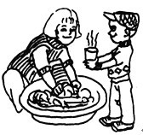

|  |  |  |  |  |  |  |  |  |  |  |  |  |  |  |  |
| --- | --- | --- | --- | --- | --- | --- | --- | --- | --- | --- | --- | --- | --- | --- | --- |
|  |  |  |  |  |  |  |  |  |  |  |  |  |  |  |  |
|  |  |  |  |  |  |  |  |  |  |  |  |  |  |  |  |
|  |  |  |  |  |  |  |  |  |  |  |  |  |  |  |  |
|  |  |  |  |  |  |  |  |  |  |  |  |  |  |  |  |
|  |  |  |  |  |  |  |  |  |  |  |  |  |  |  |  |
|  |  |  |  |  |  |  |  |  |  |  |  |  |  |  |  |
|  |  |  |  |  |  |  |  |  |  |  |  |  |  |  |  |
|  |  |  |  |  |  |  |  |  |  |  |  |  |  |  |  |
|  |  |  |  |  |  |  |  |  |  |  |  |  |  |  |  |
|  |  |  |  |  |  |  |  |  |  |  |  |  |  |  |  |

**10.**

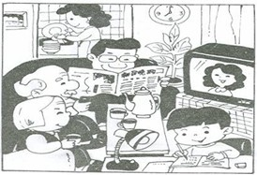

晚饭以后，东东家里可热闹了。客厅里有\_\_\_\_\_\_\_\_\_\_\_\_\_\_\_\_\_正在\_\_\_\_\_\_\_\_\_\_\_\_\_\_。\_\_\_\_\_\_\_\_\_和\_\_\_\_\_\_\_\_\_坐在\_\_\_\_\_\_\_\_上，一边喝茶一边\_\_\_\_\_\_\_\_。他们看得\_\_\_\_\_\_\_\_\_\_\_\_\_\_\_。\_\_\_\_\_\_\_\_\_\_\_\_\_正在\_\_\_\_\_\_\_\_\_\_\_\_\_ 。\_\_\_\_\_\_\_\_\_\_正在厨房里洗碗筷呢！这真是一个\_\_\_\_\_\_\_\_\_\_\_的家！

**11.**

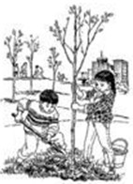**植树节**

植树节到了，同学们一大早来到\_\_\_\_\_\_\_\_\_\_\_\_\_\_\_\_\_\_\_里\_\_\_\_\_\_\_\_\_\_\_\_\_\_\_\_\_\_\_\_。李林和王洁一起\_\_\_\_\_\_\_\_\_\_\_\_\_\_\_\_\_\_\_\_。\_\_\_\_\_\_\_\_\_\_\_\_\_\_\_正在\_\_\_\_\_\_\_\_\_\_\_\_\_\_\_\_\_\_\_\_\_\_。\_\_\_\_\_\_\_\_\_\_\_\_\_\_\_\_\_正在\_\_\_\_\_\_\_\_\_\_\_\_\_\_\_\_\_\_\_\_\_\_\_\_\_\_\_\_\_。远处的同学们有的\_\_\_\_\_\_\_\_\_\_\_\_\_\_\_\_\_\_\_\_，有的\_\_\_\_\_\_\_\_\_\_\_\_\_\_\_\_\_\_\_\_\_\_，还有的\_\_\_\_\_\_\_\_\_\_\_\_\_\_\_\_\_\_\_\_\_\_\_\_\_。大家干得可带劲了！到了中午，\_\_\_\_\_\_\_\_\_\_\_\_\_\_\_\_\_\_\_\_\_\_\_\_\_\_\_\_\_\_\_\_\_\_\_。

**12.做值日**

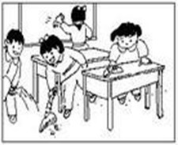

放学以后，同学们在\_\_\_\_\_\_\_\_\_\_\_\_\_\_\_\_\_\_\_\_\_\_\_\_\_\_\_\_\_。大家做得很认真，有的\_\_\_\_\_\_\_\_\_\_\_\_\_\_\_\_\_\_\_\_\_\_\_\_\_\_，有的\_\_\_\_\_\_\_\_\_\_\_\_\_\_\_\_\_\_\_\_\_\_\_\_，有的\_\_\_\_\_\_\_\_\_\_\_\_\_\_\_\_\_\_\_\_\_\_\_\_\_\_\_\_，还有的\_\_\_\_\_\_\_\_\_\_\_\_\_\_\_\_\_\_\_\_\_\_\_\_\_\_。最后，课堂被\_\_\_\_\_\_\_\_\_\_\_\_\_\_\_\_\_\_\_\_\_\_\_\_\_，大家高高兴兴地回家了。

**13.选你喜欢的一种小动物，写几句话。**

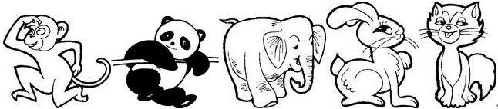

|  |  |  |  |  |  |  |  |  |  |  |  |  |  |  |  |
| --- | --- | --- | --- | --- | --- | --- | --- | --- | --- | --- | --- | --- | --- | --- | --- |
|  |  |  |  |  |  |  |  |  |  |  |  |  |  |  |  |
|  |  |  |  |  |  |  |  |  |  |  |  |  |  |  |  |
|  |  |  |  |  |  |  |  |  |  |  |  |  |  |  |  |
|  |  |  |  |  |  |  |  |  |  |  |  |  |  |  |  |
|  |  |  |  |  |  |  |  |  |  |  |  |  |  |  |  |
|  |  |  |  |  |  |  |  |  |  |  |  |  |  |  |  |
|  |  |  |  |  |  |  |  |  |  |  |  |  |  |  |  |
|  |  |  |  |  |  |  |  |  |  |  |  |  |  |  |  |

**14.你喜欢吃水果吗？选你最喜欢的一种水果，写3-5句话。用上平时积累的好词，说说它们的样子，颜色，味道，你为什么喜欢它们。**

|  |  |  |  |  |  |  |  |  |  |  |  |  |  |  |  |
| --- | --- | --- | --- | --- | --- | --- | --- | --- | --- | --- | --- | --- | --- | --- | --- |
|  |  |  |  |  |  |  |  |  |  |  |  |  |  |  |  |
|  |  |  |  |  |  |  |  |  |  |  |  |  |  |  |  |
|  |  |  |  |  |  |  |  |  |  |  |  |  |  |  |  |
|  |  |  |  |  |  |  |  |  |  |  |  |  |  |  |  |
|  |  |  |  |  |  |  |  |  |  |  |  |  |  |  |  |
|  |  |  |  |  |  |  |  |  |  |  |  |  |  |  |  |

**15.看图编故事**

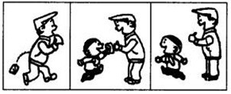

|  |  |  |  |  |  |  |  |  |  |  |  |  |  |  |  |
| --- | --- | --- | --- | --- | --- | --- | --- | --- | --- | --- | --- | --- | --- | --- | --- |
|  |  |  |  |  |  |  |  |  |  |  |  |  |  |  |  |
|  |  |  |  |  |  |  |  |  |  |  |  |  |  |  |  |
|  |  |  |  |  |  |  |  |  |  |  |  |  |  |  |  |
|  |  |  |  |  |  |  |  |  |  |  |  |  |  |  |  |
|  |  |  |  |  |  |  |  |  |  |  |  |  |  |  |  |
|  |  |  |  |  |  |  |  |  |  |  |  |  |  |  |  |
|  |  |  |  |  |  |  |  |  |  |  |  |  |  |  |  |
|  |  |  |  |  |  |  |  |  |  |  |  |  |  |  |  |

**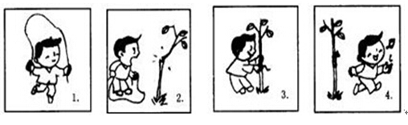16.**

|  |  |  |  |  |  |  |  |  |  |  |  |  |  |  |  |
| --- | --- | --- | --- | --- | --- | --- | --- | --- | --- | --- | --- | --- | --- | --- | --- |
|  |  |  |  |  |  |  |  |  |  |  |  |  |  |  |  |
|  |  |  |  |  |  |  |  |  |  |  |  |  |  |  |  |
|  |  |  |  |  |  |  |  |  |  |  |  |  |  |  |  |
|  |  |  |  |  |  |  |  |  |  |  |  |  |  |  |  |
|  |  |  |  |  |  |  |  |  |  |  |  |  |  |  |  |
|  |  |  |  |  |  |  |  |  |  |  |  |  |  |  |  |
|  |  |  |  |  |  |  |  |  |  |  |  |  |  |  |  |
|  |  |  |  |  |  |  |  |  |  |  |  |  |  |  |  |
|  |  |  |  |  |  |  |  |  |  |  |  |  |  |  |  |
|  |  |  |  |  |  |  |  |  |  |  |  |  |  |  |  |

**17．**

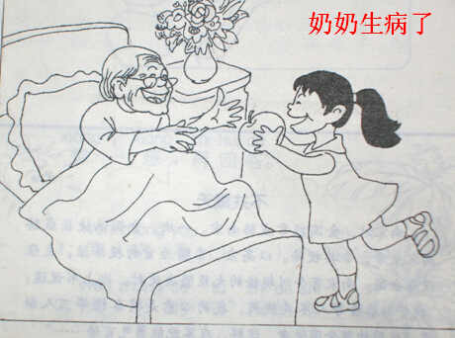

|  |  |  |  |  |  |  |  |  |  |  |  |  |  |  |  |
| --- | --- | --- | --- | --- | --- | --- | --- | --- | --- | --- | --- | --- | --- | --- | --- |
|  |  |  |  |  |  |  |  |  |  |  |  |  |  |  |  |
|  |  |  |  |  |  |  |  |  |  |  |  |  |  |  |  |
|  |  |  |  |  |  |  |  |  |  |  |  |  |  |  |  |
|  |  |  |  |  |  |  |  |  |  |  |  |  |  |  |  |
|  |  |  |  |  |  |  |  |  |  |  |  |  |  |  |  |
|  |  |  |  |  |  |  |  |  |  |  |  |  |  |  |  |
|  |  |  |  |  |  |  |  |  |  |  |  |  |  |  |  |
|  |  |  |  |  |  |  |  |  |  |  |  |  |  |  |  |
|  |  |  |  |  |  |  |  |  |  |  |  |  |  |  |  |
|  |  |  |  |  |  |  |  |  |  |  |  |  |  |  |  |

**18．**

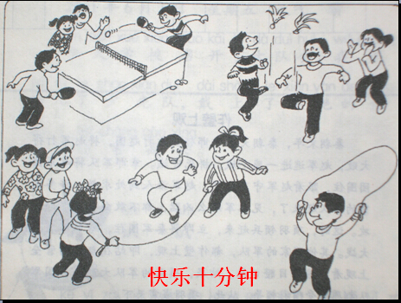

|  |  |  |  |  |  |  |  |  |  |  |  |  |  |  |  |
| --- | --- | --- | --- | --- | --- | --- | --- | --- | --- | --- | --- | --- | --- | --- | --- |
|  |  |  |  |  |  |  |  |  |  |  |  |  |  |  |  |
|  |  |  |  |  |  |  |  |  |  |  |  |  |  |  |  |
|  |  |  |  |  |  |  |  |  |  |  |  |  |  |  |  |
|  |  |  |  |  |  |  |  |  |  |  |  |  |  |  |  |
|  |  |  |  |  |  |  |  |  |  |  |  |  |  |  |  |
|  |  |  |  |  |  |  |  |  |  |  |  |  |  |  |  |
|  |  |  |  |  |  |  |  |  |  |  |  |  |  |  |  |
|  |  |  |  |  |  |  |  |  |  |  |  |  |  |  |  |
|  |  |  |  |  |  |  |  |  |  |  |  |  |  |  |  |
|  |  |  |  |  |  |  |  |  |  |  |  |  |  |  |  |

**19．**

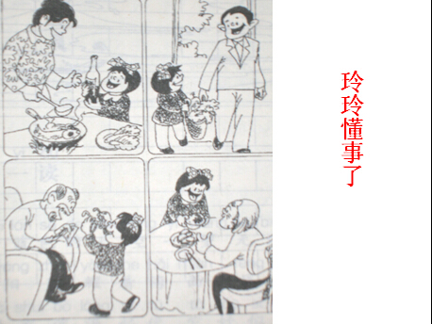

|  |  |  |  |  |  |  |  |  |  |  |  |  |  |  |  |
| --- | --- | --- | --- | --- | --- | --- | --- | --- | --- | --- | --- | --- | --- | --- | --- |
|  |  |  |  |  |  |  |  |  |  |  |  |  |  |  |  |
|  |  |  |  |  |  |  |  |  |  |  |  |  |  |  |  |
|  |  |  |  |  |  |  |  |  |  |  |  |  |  |  |  |
|  |  |  |  |  |  |  |  |  |  |  |  |  |  |  |  |
|  |  |  |  |  |  |  |  |  |  |  |  |  |  |  |  |
|  |  |  |  |  |  |  |  |  |  |  |  |  |  |  |  |
|  |  |  |  |  |  |  |  |  |  |  |  |  |  |  |  |
|  |  |  |  |  |  |  |  |  |  |  |  |  |  |  |  |
|  |  |  |  |  |  |  |  |  |  |  |  |  |  |  |  |
|  |  |  |  |  |  |  |  |  |  |  |  |  |  |  |  |

**20．**

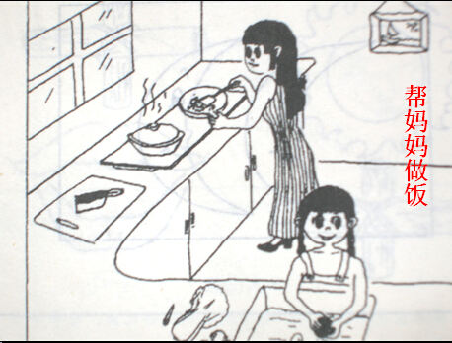

|  |  |  |  |  |  |  |  |  |  |  |  |  |  |  |  |
| --- | --- | --- | --- | --- | --- | --- | --- | --- | --- | --- | --- | --- | --- | --- | --- |
|  |  |  |  |  |  |  |  |  |  |  |  |  |  |  |  |
|  |  |  |  |  |  |  |  |  |  |  |  |  |  |  |  |
|  |  |  |  |  |  |  |  |  |  |  |  |  |  |  |  |
|  |  |  |  |  |  |  |  |  |  |  |  |  |  |  |  |
|  |  |  |  |  |  |  |  |  |  |  |  |  |  |  |  |
|  |  |  |  |  |  |  |  |  |  |  |  |  |  |  |  |
|  |  |  |  |  |  |  |  |  |  |  |  |  |  |  |  |
|  |  |  |  |  |  |  |  |  |  |  |  |  |  |  |  |
|  |  |  |  |  |  |  |  |  |  |  |  |  |  |  |  |
|  |  |  |  |  |  |  |  |  |  |  |  |  |  |  |  |

**21．**

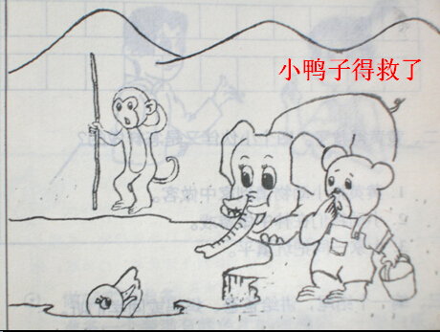

|  |  |  |  |  |  |  |  |  |  |  |  |  |  |  |  |
| --- | --- | --- | --- | --- | --- | --- | --- | --- | --- | --- | --- | --- | --- | --- | --- |
|  |  |  |  |  |  |  |  |  |  |  |  |  |  |  |  |
|  |  |  |  |  |  |  |  |  |  |  |  |  |  |  |  |
|  |  |  |  |  |  |  |  |  |  |  |  |  |  |  |  |
|  |  |  |  |  |  |  |  |  |  |  |  |  |  |  |  |
|  |  |  |  |  |  |  |  |  |  |  |  |  |  |  |  |
|  |  |  |  |  |  |  |  |  |  |  |  |  |  |  |  |
|  |  |  |  |  |  |  |  |  |  |  |  |  |  |  |  |
|  |  |  |  |  |  |  |  |  |  |  |  |  |  |  |  |
|  |  |  |  |  |  |  |  |  |  |  |  |  |  |  |  |
|  |  |  |  |  |  |  |  |  |  |  |  |  |  |  |  |

**22．**

**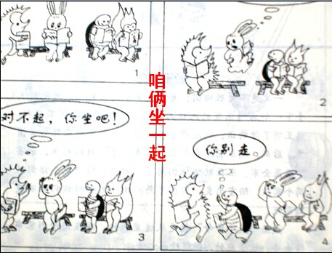**

|  |  |  |  |  |  |  |  |  |  |  |  |  |  |  |  |
| --- | --- | --- | --- | --- | --- | --- | --- | --- | --- | --- | --- | --- | --- | --- | --- |
|  |  |  |  |  |  |  |  |  |  |  |  |  |  |  |  |
|  |  |  |  |  |  |  |  |  |  |  |  |  |  |  |  |
|  |  |  |  |  |  |  |  |  |  |  |  |  |  |  |  |
|  |  |  |  |  |  |  |  |  |  |  |  |  |  |  |  |
|  |  |  |  |  |  |  |  |  |  |  |  |  |  |  |  |
|  |  |  |  |  |  |  |  |  |  |  |  |  |  |  |  |
|  |  |  |  |  |  |  |  |  |  |  |  |  |  |  |  |
|  |  |  |  |  |  |  |  |  |  |  |  |  |  |  |  |
|  |  |  |  |  |  |  |  |  |  |  |  |  |  |  |  |
|  |  |  |  |  |  |  |  |  |  |  |  |  |  |  |  |

**23．**

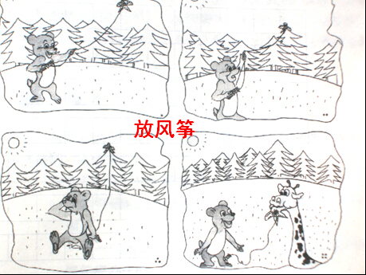

|  |  |  |  |  |  |  |  |  |  |  |  |  |  |  |  |
| --- | --- | --- | --- | --- | --- | --- | --- | --- | --- | --- | --- | --- | --- | --- | --- |
|  |  |  |  |  |  |  |  |  |  |  |  |  |  |  |  |
|  |  |  |  |  |  |  |  |  |  |  |  |  |  |  |  |
|  |  |  |  |  |  |  |  |  |  |  |  |  |  |  |  |
|  |  |  |  |  |  |  |  |  |  |  |  |  |  |  |  |
|  |  |  |  |  |  |  |  |  |  |  |  |  |  |  |  |
|  |  |  |  |  |  |  |  |  |  |  |  |  |  |  |  |
|  |  |  |  |  |  |  |  |  |  |  |  |  |  |  |  |
|  |  |  |  |  |  |  |  |  |  |  |  |  |  |  |  |
|  |  |  |  |  |  |  |  |  |  |  |  |  |  |  |  |
|  |  |  |  |  |  |  |  |  |  |  |  |  |  |  |  |

**24．**

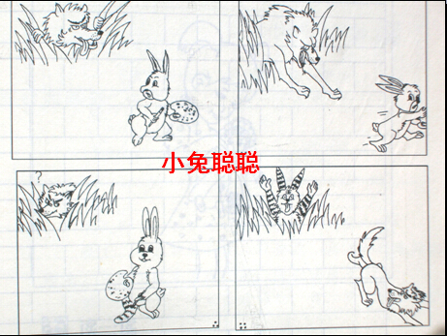

|  |  |  |  |  |  |  |  |  |  |  |  |  |  |  |  |
| --- | --- | --- | --- | --- | --- | --- | --- | --- | --- | --- | --- | --- | --- | --- | --- |
|  |  |  |  |  |  |  |  |  |  |  |  |  |  |  |  |
|  |  |  |  |  |  |  |  |  |  |  |  |  |  |  |  |
|  |  |  |  |  |  |  |  |  |  |  |  |  |  |  |  |
|  |  |  |  |  |  |  |  |  |  |  |  |  |  |  |  |
|  |  |  |  |  |  |  |  |  |  |  |  |  |  |  |  |
|  |  |  |  |  |  |  |  |  |  |  |  |  |  |  |  |
|  |  |  |  |  |  |  |  |  |  |  |  |  |  |  |  |
|  |  |  |  |  |  |  |  |  |  |  |  |  |  |  |  |
|  |  |  |  |  |  |  |  |  |  |  |  |  |  |  |  |
|  |  |  |  |  |  |  |  |  |  |  |  |  |  |  |  |

**25．**

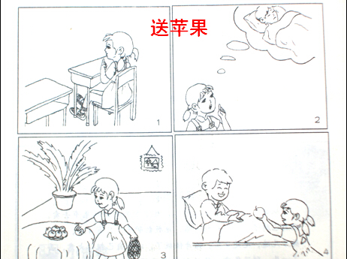

|  |  |  |  |  |  |  |  |  |  |  |  |  |  |  |  |
| --- | --- | --- | --- | --- | --- | --- | --- | --- | --- | --- | --- | --- | --- | --- | --- |
|  |  |  |  |  |  |  |  |  |  |  |  |  |  |  |  |
|  |  |  |  |  |  |  |  |  |  |  |  |  |  |  |  |
|  |  |  |  |  |  |  |  |  |  |  |  |  |  |  |  |
|  |  |  |  |  |  |  |  |  |  |  |  |  |  |  |  |
|  |  |  |  |  |  |  |  |  |  |  |  |  |  |  |  |
|  |  |  |  |  |  |  |  |  |  |  |  |  |  |  |  |
|  |  |  |  |  |  |  |  |  |  |  |  |  |  |  |  |
|  |  |  |  |  |  |  |  |  |  |  |  |  |  |  |  |
|  |  |  |  |  |  |  |  |  |  |  |  |  |  |  |  |
|  |  |  |  |  |  |  |  |  |  |  |  |  |  |  |  |

**26．**

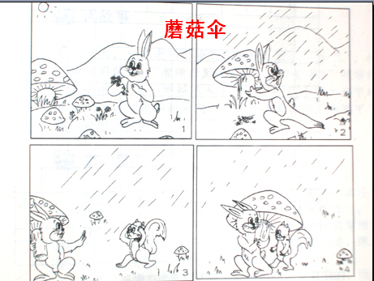

|  |  |  |  |  |  |  |  |  |  |  |  |  |  |  |  |
| --- | --- | --- | --- | --- | --- | --- | --- | --- | --- | --- | --- | --- | --- | --- | --- |
|  |  |  |  |  |  |  |  |  |  |  |  |  |  |  |  |
|  |  |  |  |  |  |  |  |  |  |  |  |  |  |  |  |
|  |  |  |  |  |  |  |  |  |  |  |  |  |  |  |  |
|  |  |  |  |  |  |  |  |  |  |  |  |  |  |  |  |
|  |  |  |  |  |  |  |  |  |  |  |  |  |  |  |  |
|  |  |  |  |  |  |  |  |  |  |  |  |  |  |  |  |
|  |  |  |  |  |  |  |  |  |  |  |  |  |  |  |  |
|  |  |  |  |  |  |  |  |  |  |  |  |  |  |  |  |
|  |  |  |  |  |  |  |  |  |  |  |  |  |  |  |  |
|  |  |  |  |  |  |  |  |  |  |  |  |  |  |  |  |

**27．**

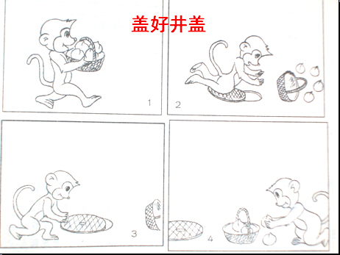

|  |  |  |  |  |  |  |  |  |  |  |  |  |  |  |  |
| --- | --- | --- | --- | --- | --- | --- | --- | --- | --- | --- | --- | --- | --- | --- | --- |
|  |  |  |  |  |  |  |  |  |  |  |  |  |  |  |  |
|  |  |  |  |  |  |  |  |  |  |  |  |  |  |  |  |
|  |  |  |  |  |  |  |  |  |  |  |  |  |  |  |  |
|  |  |  |  |  |  |  |  |  |  |  |  |  |  |  |  |
|  |  |  |  |  |  |  |  |  |  |  |  |  |  |  |  |
|  |  |  |  |  |  |  |  |  |  |  |  |  |  |  |  |
|  |  |  |  |  |  |  |  |  |  |  |  |  |  |  |  |
|  |  |  |  |  |  |  |  |  |  |  |  |  |  |  |  |
|  |  |  |  |  |  |  |  |  |  |  |  |  |  |  |  |
|  |  |  |  |  |  |  |  |  |  |  |  |  |  |  |  |

**28．**

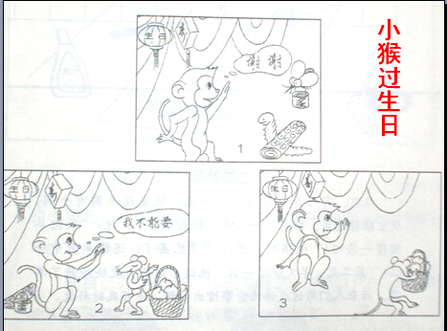

|  |  |  |  |  |  |  |  |  |  |  |  |  |  |  |  |
| --- | --- | --- | --- | --- | --- | --- | --- | --- | --- | --- | --- | --- | --- | --- | --- |
|  |  |  |  |  |  |  |  |  |  |  |  |  |  |  |  |
|  |  |  |  |  |  |  |  |  |  |  |  |  |  |  |  |
|  |  |  |  |  |  |  |  |  |  |  |  |  |  |  |  |
|  |  |  |  |  |  |  |  |  |  |  |  |  |  |  |  |
|  |  |  |  |  |  |  |  |  |  |  |  |  |  |  |  |
|  |  |  |  |  |  |  |  |  |  |  |  |  |  |  |  |
|  |  |  |  |  |  |  |  |  |  |  |  |  |  |  |  |
|  |  |  |  |  |  |  |  |  |  |  |  |  |  |  |  |
|  |  |  |  |  |  |  |  |  |  |  |  |  |  |  |  |
|  |  |  |  |  |  |  |  |  |  |  |  |  |  |  |  |

**29．**

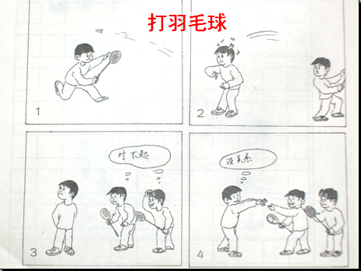

|  |  |  |  |  |  |  |  |  |  |  |  |  |  |  |  |
| --- | --- | --- | --- | --- | --- | --- | --- | --- | --- | --- | --- | --- | --- | --- | --- |
|  |  |  |  |  |  |  |  |  |  |  |  |  |  |  |  |
|  |  |  |  |  |  |  |  |  |  |  |  |  |  |  |  |
|  |  |  |  |  |  |  |  |  |  |  |  |  |  |  |  |
|  |  |  |  |  |  |  |  |  |  |  |  |  |  |  |  |
|  |  |  |  |  |  |  |  |  |  |  |  |  |  |  |  |
|  |  |  |  |  |  |  |  |  |  |  |  |  |  |  |  |
|  |  |  |  |  |  |  |  |  |  |  |  |  |  |  |  |
|  |  |  |  |  |  |  |  |  |  |  |  |  |  |  |  |
|  |  |  |  |  |  |  |  |  |  |  |  |  |  |  |  |
|  |  |  |  |  |  |  |  |  |  |  |  |  |  |  |  |

**30．**

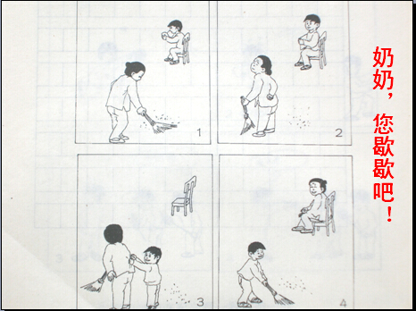

|  |  |  |  |  |  |  |  |  |  |  |  |  |  |  |  |
| --- | --- | --- | --- | --- | --- | --- | --- | --- | --- | --- | --- | --- | --- | --- | --- |
|  |  |  |  |  |  |  |  |  |  |  |  |  |  |  |  |
|  |  |  |  |  |  |  |  |  |  |  |  |  |  |  |  |
|  |  |  |  |  |  |  |  |  |  |  |  |  |  |  |  |
|  |  |  |  |  |  |  |  |  |  |  |  |  |  |  |  |
|  |  |  |  |  |  |  |  |  |  |  |  |  |  |  |  |
|  |  |  |  |  |  |  |  |  |  |  |  |  |  |  |  |
|  |  |  |  |  |  |  |  |  |  |  |  |  |  |  |  |
|  |  |  |  |  |  |  |  |  |  |  |  |  |  |  |  |
|  |  |  |  |  |  |  |  |  |  |  |  |  |  |  |  |
|  |  |  |  |  |  |  |  |  |  |  |  |  |  |  |  |

**31．**

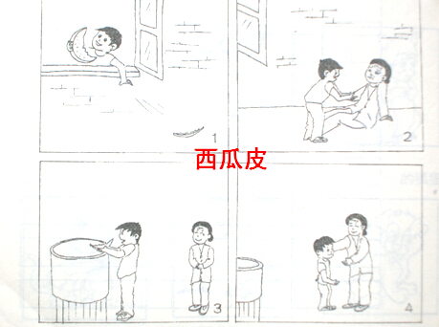

|  |  |  |  |  |  |  |  |  |  |  |  |  |  |  |  |
| --- | --- | --- | --- | --- | --- | --- | --- | --- | --- | --- | --- | --- | --- | --- | --- |
|  |  |  |  |  |  |  |  |  |  |  |  |  |  |  |  |
|  |  |  |  |  |  |  |  |  |  |  |  |  |  |  |  |
|  |  |  |  |  |  |  |  |  |  |  |  |  |  |  |  |
|  |  |  |  |  |  |  |  |  |  |  |  |  |  |  |  |
|  |  |  |  |  |  |  |  |  |  |  |  |  |  |  |  |
|  |  |  |  |  |  |  |  |  |  |  |  |  |  |  |  |
|  |  |  |  |  |  |  |  |  |  |  |  |  |  |  |  |
|  |  |  |  |  |  |  |  |  |  |  |  |  |  |  |  |
|  |  |  |  |  |  |  |  |  |  |  |  |  |  |  |  |
|  |  |  |  |  |  |  |  |  |  |  |  |  |  |  |  |

**32．**

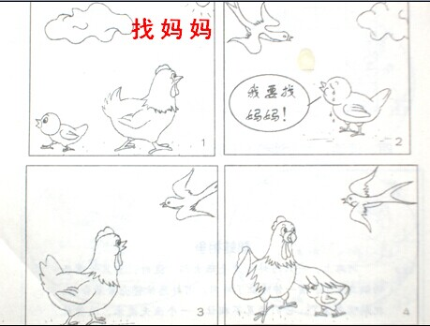

|  |  |  |  |  |  |  |  |  |  |  |  |  |  |  |  |
| --- | --- | --- | --- | --- | --- | --- | --- | --- | --- | --- | --- | --- | --- | --- | --- |
|  |  |  |  |  |  |  |  |  |  |  |  |  |  |  |  |
|  |  |  |  |  |  |  |  |  |  |  |  |  |  |  |  |
|  |  |  |  |  |  |  |  |  |  |  |  |  |  |  |  |
|  |  |  |  |  |  |  |  |  |  |  |  |  |  |  |  |
|  |  |  |  |  |  |  |  |  |  |  |  |  |  |  |  |
|  |  |  |  |  |  |  |  |  |  |  |  |  |  |  |  |
|  |  |  |  |  |  |  |  |  |  |  |  |  |  |  |  |
|  |  |  |  |  |  |  |  |  |  |  |  |  |  |  |  |
|  |  |  |  |  |  |  |  |  |  |  |  |  |  |  |  |
|  |  |  |  |  |  |  |  |  |  |  |  |  |  |  |  |

**33．**

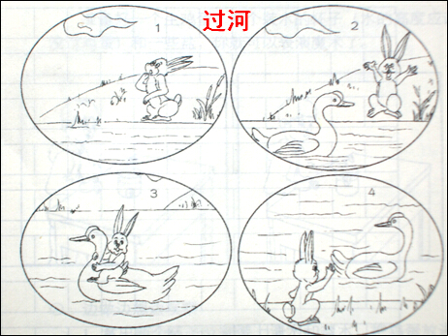

|  |  |  |  |  |  |  |  |  |  |  |  |  |  |  |  |
| --- | --- | --- | --- | --- | --- | --- | --- | --- | --- | --- | --- | --- | --- | --- | --- |
|  |  |  |  |  |  |  |  |  |  |  |  |  |  |  |  |
|  |  |  |  |  |  |  |  |  |  |  |  |  |  |  |  |
|  |  |  |  |  |  |  |  |  |  |  |  |  |  |  |  |
|  |  |  |  |  |  |  |  |  |  |  |  |  |  |  |  |
|  |  |  |  |  |  |  |  |  |  |  |  |  |  |  |  |
|  |  |  |  |  |  |  |  |  |  |  |  |  |  |  |  |
|  |  |  |  |  |  |  |  |  |  |  |  |  |  |  |  |
|  |  |  |  |  |  |  |  |  |  |  |  |  |  |  |  |
|  |  |  |  |  |  |  |  |  |  |  |  |  |  |  |  |
|  |  |  |  |  |  |  |  |  |  |  |  |  |  |  |  |

**34．**



                                
                                
                                
                                
                                
                                
                                
                                
                                
                                
                                
                                