写话与口语交际

一、 看图写话。(10分)

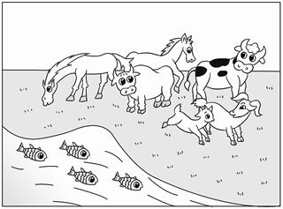

提示：图上都有什么？它们分别在干什么？

|  |  |  |  |  |  |  |  |  |  |  |  |  |  |
| --- | --- | --- | --- | --- | --- | --- | --- | --- | --- | --- | --- | --- | --- |
|  |  |  |  |  |  |  |  |  |  |  |  |  |  |
|  |  |  |  |  |  |  |  |  |  |  |  |  |  |
|  |  |  |  |  |  |  |  |  |  |  |  |  |  |
|  |  |  |  |  |  |  |  |  |  |  |  |  |  |
|  |  |  |  |  |  |  |  |  |  |  |  |  |  |

二、看图，补充写话。(8分)

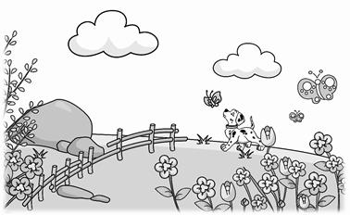

春天到了，小树发出新的枝芽。__________的草地上盛开着五颜六色的花朵，有_________、_________、_________，美丽极了。_________的天空飘着_________的云朵。_____ ___的蝴蝶在花丛中飞舞。一只小狗在地上____________。我喜欢这美丽的春天！

三、看图，选择一种动物写一写。(7分)

　 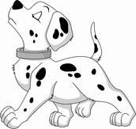　　　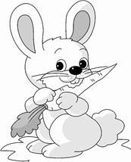

我最喜欢的动物是__________，它长着___________的耳朵，________ __的眼睛，____________的嘴，还有____________。它浑身长着___________的毛，走起路来_____________ ，真是可爱极了！

四、看图写话。(10分)

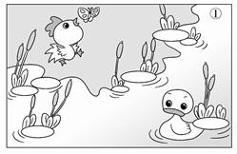 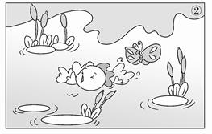

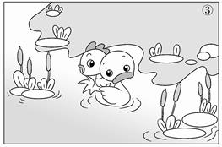 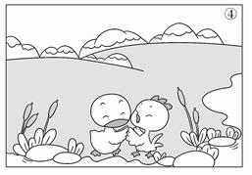

|  |  |  |  |  |  |  |  |  |  |  |  |  |  |
| --- | --- | --- | --- | --- | --- | --- | --- | --- | --- | --- | --- | --- | --- |
|  |  |  |  |  |  |  |  |  |  |  |  |  |  |
|  |  |  |  |  |  |  |  |  |  |  |  |  |  |
|  |  |  |  |  |  |  |  |  |  |  |  |  |  |
|  |  |  |  |  |  |  |  |  |  |  |  |  |  |
|  |  |  |  |  |  |  |  |  |  |  |  |  |  |
|  |  |  |  |  |  |  |  |  |  |  |  |  |  |
|  |  |  |  |  |  |  |  |  |  |  |  |  |  |
|  |  |  |  |  |  |  |  |  |  |  |  |  |  |

五、今天，明明邀请你去他家做客，你知道该怎样做吗？(4分)

 A．走到明明家门口，你要___________________________ 。

B．明明打开门，你说：“____________________________________！”

C．明明拿来水果让你吃，你说：“__________________________________！”

D．你要走了，对明明说：“________________________________________！”

六、假如你今天生病了，要向老师请假，给老师打电话该怎样说呢？最好用上“您好”“谢谢”“再见”等礼貌用语。(5分)

你：“___________________________________________________________”

老师：“______________________________________________________”

你：“___________________________________________________________”

老师：“__________________________________________________________”

你：“____________________________________________________________”

七、如果是你。(6分) 绿　色　圃　中　小　学　教　育　网h　t　t　p　:　/　/　w　w　w　.　l　s　p　j　y　.　c　o　m

有一天，你不小心摔倒了。这时，明明跑过来，扶起了你，并关切地问：“怎么样，没受伤吧？”

你会说：“________________________________________________________。”

明明说：“朋友之间互相帮助是应该的。”

你会想：__________________________________________________________。

当别人遇到困难时……

你会______________________________________________________________。

八、仔细观察图画内容，完成写话



                            
                            
                            
                            
                            
                            
                            
                            